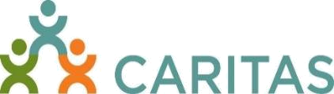

Forklift Certification Training

CARITAS offers certification courses (6 hours) throughout the year for anyone who will operate sit-down forklifts (powered industrial trucks). Upon successful completion of the course and testing, the participant will receive both a wallet size and an 8X10 certificate valid in Virginia.

The class participants, through hands-on and classroom experiences will be able to:

- Operate powered industrial trucks, forklifts

- Understand and utilize OSHA standards for operating forklifts

- Learn about the different types of forklifts and how to correctly perform pre and post operation inspections

- Drive, park, load, inspect, and stabilize forklifts

- Understand safety procedures and operator warnings for forklifts Develop and utilize a daily checklist for forklifts

2023 Saturday Dates
All trainings 8 am – 2 pm

January 21, March 18, May 20,
July 15, September 16 and November 18

The CARITAS Center
2220 Stockton St., Richmond, VA 23224

$85 per person- training materials included
Minimum Class Size: 12

To register: email or call Sandra Morris smorris@caritasva.org (804) 358-0964

